**Abstract**

CredGo is an innovative web-based platform that transforms the traditional approach to volunteerism by recognizing time as a valuable currency. The platform enables users to offer their skills and time as volunteers, earn credits called "Creds," and redeem those credits to avail services from other users in the community. This time-banking system fosters a culture of kindness, mutual aid, and community empowerment.

The aim of CredGo is not only to connect people but also to value human effort and time in a meaningful way, shifting focus from traditional monetary exchanges to a more inclusive and service-oriented ecosystem. It provides a digital framework for managing volunteer activities, tracking time-based contributions, and ensuring transparency in Cred transactions. The platform promotes equitable service exchange and builds a network of trust and collaboration.

With Firebase for backend services and a responsive frontend interface, CredGo ensures seamless interactions, secure authentication, and real-time data updates. The application was developed using the Agile methodology, enabling rapid iterations and feedback incorporation. Various levels of testing including unit, integration, and user acceptance tests have been employed to ensure robustness, reliability, and user satisfaction.

**Table of Contents**

1. Introduction
2. Objectives
3. Target Audience
4. System Overview
5. Software Architecture
6. Development Model
7. Testing Methodology
8. UML Diagrams
9. Conclusion
10. Future Scope
11. Individual Contributions
12. References
13. **Introduction**

In today's rapidly evolving digital world, the spirit of community service often lacks recognition and reward. Many individuals want to contribute their time and skills but are deterred due to a lack of meaningful acknowledgment or sustainable exchange mechanisms. Traditional volunteer platforms often fail to incentivize sustained engagement, leading to inconsistent participation and undervaluation of volunteer contributions.

CredGo addresses this gap by offering a platform where services are exchanged not for money, but for time. The core philosophy of CredGo is simple yet powerful: volunteer one hour of your time, and earn one "credit" to be used later for a service you need. This system democratizes access to skills and services while fostering a strong sense of community. Unlike monetary systems, this model values everyone's time equally, regardless of the type of service offered, creating a truly inclusive and egalitarian network.

The idea was born from the concept of time banking, which has been successfully used in various countries to encourage local cooperation and community development. By leveraging digital technology and cloud-based services, CredGo brings this concept to the modern age. Users are not only able to give and receive services, but also build their personal and professional networks, improve their skillsets, and gain a sense of fulfillment by helping others.

CredGo's architecture ensures a seamless user experience and robust backend infrastructure using Firebase, allowing real-time updates and secure authentication. By promoting mutual aid, CredGo redefines how we perceive value and service in our daily lives and opens up new avenues for community-driven collaboration and growth.

1. **Objectives**

* To develop a sustainable, community-driven platform that values time as currency.
* To empower individuals to exchange their time and skills meaningfully.
* To recognize and reward volunteer efforts in a non-monetary format.
* To promote a culture of mutual help, collaboration, and social contribution.
* To build an intuitive, secure, and responsive web platform for ease of access and

real-time tracking of activities.

1. **Target Audience**

CredGo caters to a wide range of users by bridging the gap between those who want to help and those in need of support, making it an inclusive and accessible platform for individuals and organizations from diverse backgrounds. CredGo provides a welcoming space to connect and collaborate:

* Students and Young Professionals: Who want to gain experience or contribute meaningfully.
* Non-profits and NGOs: In need of skilled volunteers.
* Freelancers and Skill-based Volunteers: Looking to offer services and receive help in return.
* Community Groups: That want to encourage internal support mechanisms.

1. **System Overview**

CredGo is a fully functional web application designed to facilitate the exchange of time and skills, helping users to engage in meaningful service-based interactions without the use of money. The system provides a user-friendly digital platform where individuals can register, offer help in the form of skill-based tasks, and request services in return. Each activity within the system is securely tracked, ensuring that both time and service contributions are recognized and rewarded.

The platform’s architecture is designed to offer seamless navigation and transparency. From initial sign-up to final service delivery, each step of the process is managed in real time through robust backend support. CredGo uses a unique credit-based reward system that logs every volunteer hour, allowing users to accumulate credits that can be used later to receive services from others in the network. This model encourages continued participation and creates a circular ecosystem of help and support.

In addition, the system allows users to view active requests, service history, and current credit balances via an intuitive dashboard. The credit system ensures fairness and avoids monetary bias, making the platform inclusive and equitable. Community impact is further amplified through built-in activity logs and service ratings that promote accountability and trust.

Key components of the system include:

* **User Registration and Authentication** using Firebase Authentication to ensure secure sign-ins.
* **Service Listings** where users can post their available skills or request help.
* **Credit Tracking System** to monitor earned and spent credits with real-time updates.
* **Request and Matchmaking System** that intelligently connects users based on their needs and offerings.
* **Activity Logs and Dashboards** that provide insights into service history, user engagement, and contribution records

1. **Software Architecture**

**Frontend:**

Developed using HTML, CSS, and JavaScript with a focus on responsive design. The frontend features intuitive navigation, clean layout structures, and interactive forms for logging in, posting services, and tracking credit balances. Future updates may include React.js for modular and dynamic UI components.

Below are a few user interface (UI) images showcasing the design and layout of the frontend components of the CredGo platform, such as the homepage, service posting form, and dashboard view. These visuals offer insights into the user journey and interaction flow.

**Backend:**

Firebase is used for Authentication and Firestore for real-time database management. All service data, user profiles, and credit transactions are stored and retrieved efficiently. The backend provides seamless integration with the frontend, enabling real-time updates across users and services. Firebase Hosting is used to deploy and serve the web application with minimal setup and strong security.

Below are a few images showcasing the Firebase Firestore setup showing collections and documents used in CredGo for storing user, service, and transaction data.

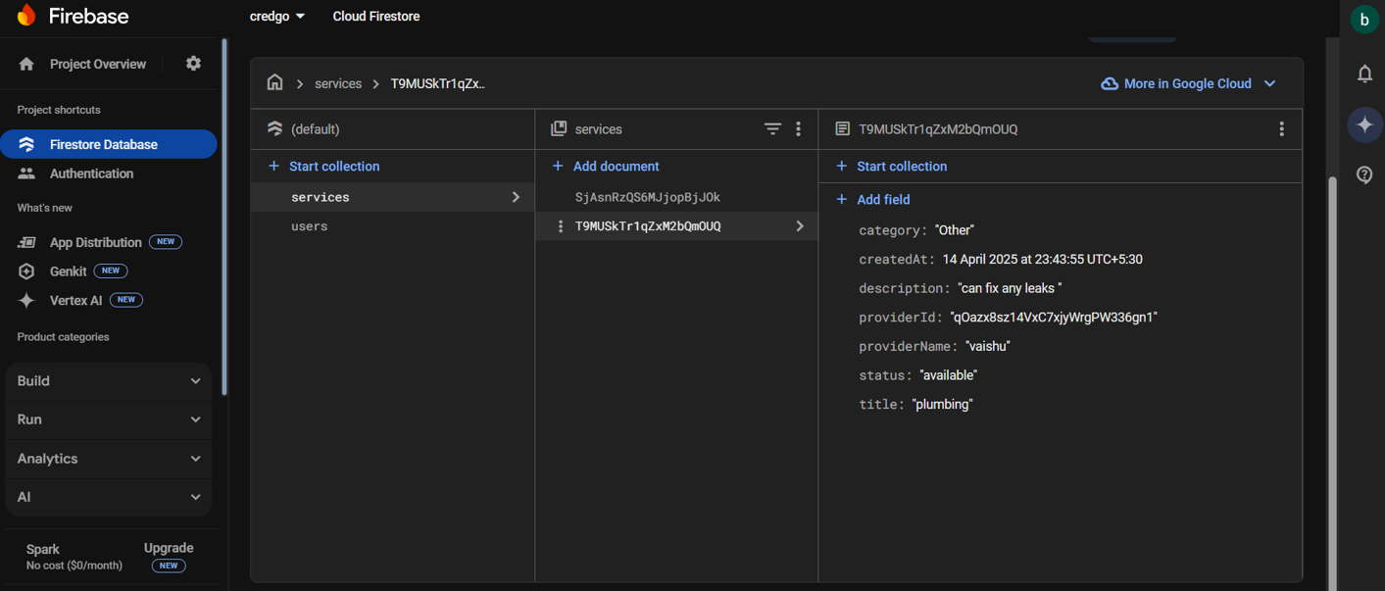 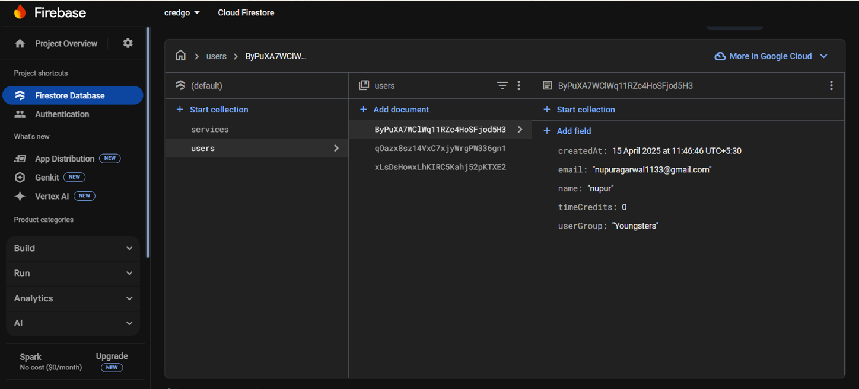

**Deployment:**

CredGo was deployed using **Firebase Hosting**, which provides a fast, secure, and scalable hosting solution for web apps. Using the Firebase CLI, the production build was deployed and linked with a custom domain. Firebase ensures HTTPS by default, allowing users to securely access the platform from any device. Deployment also includes versioning support and detailed logs to monitor deployment status.

Below are a few code images from the CredGo project that highlight key implementation areas such as Firebase initialization, authentication logic, and real-time credit transactions. These provide a behind-the-scenes look at how the application functions at the code level:

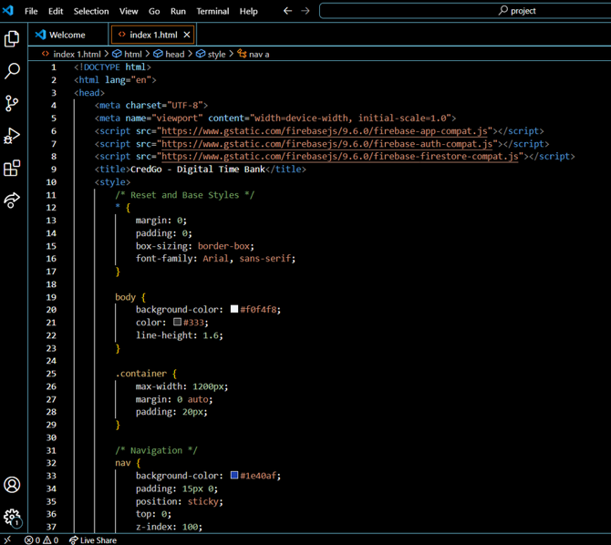

1. **Software Development Model**

CredGo was developed using the **Agile Software Development Model**. Agile promotes adaptive planning, evolutionary development, early delivery, and continual improvement. This model was selected to accommodate frequent changes based on testing, user feedback, and team brainstorming.

Each phase of development was structured into **sprints**, typically lasting one week. During each sprint:

* New features (e.g., service posting, credit tracking) were developed and tested.
* Feedback was collected from peers and mentors.
* Improvements were applied in the following sprint.

Agile helped the team stay flexible, incorporate changes easily, and incrementally build a user-friendly platform.

Reason for selection:

* Allows continuous improvement through user feedback.
* Encourages collaboration and flexible design.
* Supports incremental delivery of features in sprints.

1. **Software Testing**

CredGo follows a structured testing approach to ensure that the application is robust, secure, and user-friendly.

* Sprint-wise Testing: Each sprint concluded with testing of new features like login, posting services, and Cred transactions.
* Unit Testing: Individual components such as authentication, form validations, and Cred calculations were tested in isolation.
* Integration Testing: Ensured seamless interaction between different modules, like syncing Cred transactions with service requests.
* User Acceptance Testing (UAT): Real users tested the app to provide feedback on usability, design, and performance.
* Functional Testing: Each of the features were tested against its requirements, like checking if service posting actually saves and display the right information.

Tools Used:

* Manual Testing
* Firebase Console for database checks
* Browser Developer Tools for frontend debugging

1. **UML Diagrams**
2. **Use Case Diagram**

Describes the interactions between users- Retired Individuals, Stay-at-home Individuals, Youngsters with the system- Admin, Platform. Use cases include: Registration, Login, Authentication, Matchmaking, Admin Management, Report Issues, Platform Maintenance.

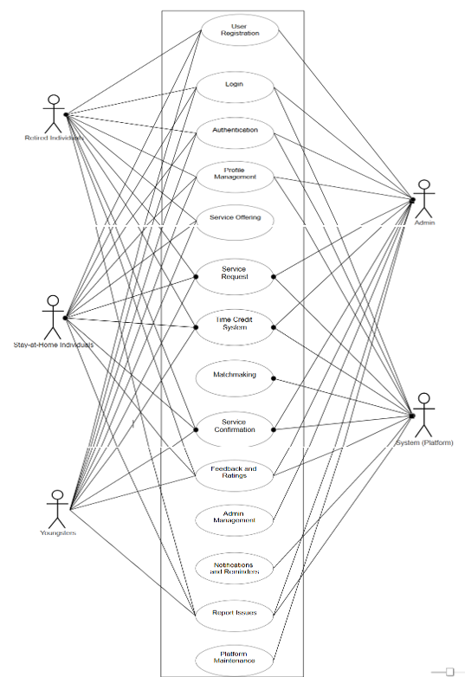

1. **Class Diagram**

Defines the structure of the system by showing system classes, attributes, methods, and the relationships between objects.

Main classes: User, Service, Admin, Matchmaking, Database, Time Credit, Feedback.

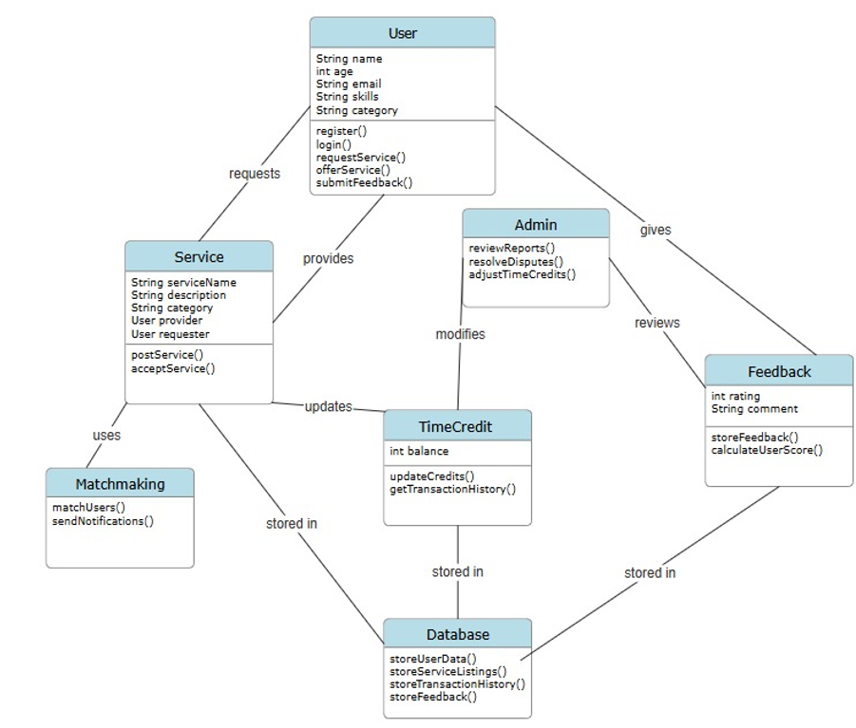

1. **Activity Diagram**

Demonstrates the workflow of a user posting a service and earning Creds, till the user feedback.

Flow: Login → Service Request → Granted→ Service Completed

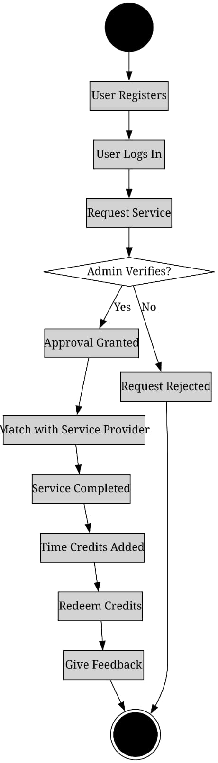

1. **Sequence Diagram**

Depicts the sequence of messages exchanged between user interface, backend, and database when a user requests a service or tries to log-in or if tried to redeem credits.

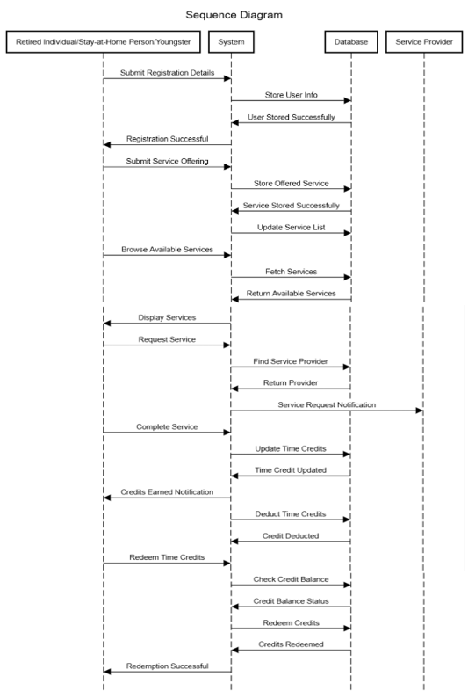

1. **State Diagram**

Illustrates the states – Registration state, Verification state, Service Exchange state, Time Credit Updation.

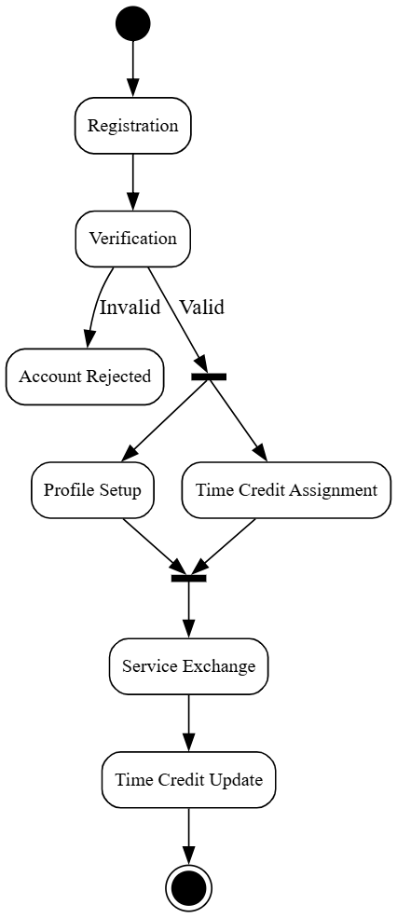

1. **ER Diagram**

The ER Diagram for CredGo shows entities like User, Admin, Service, and Request, and their relationships. It helps in understanding the structure of data and how they interact in the system. Following is the diagram:

1. **Collaborative Diagram**

It illustrates how components of the CredGo system communicate during a process, such as a user logging in. It shows how the User Interface, Authentication Service, and Database work together to verify user credentials and allow access.

1. **Conclusion**

CredGo offers a fresh perspective on volunteerism by transforming time into a valuable, trackable asset. By enabling users to exchange skills and services without relying on money, it fosters community development, inclusion, and mutual respect.

Leveraging Firebase’s secure, real-time features for backend services, CredGo ensures a reliable and scalable infrastructure. The platform’s responsive, user-friendly interface enhances the overall user experience. Through flexible development and continuous feedback, CredGo has been iteratively refined, making it ready for real-world application and potential mobile app expansion.

CredGo successfully embodies the concept of a time-banking platform, where time becomes a currency. It empowers individuals to contribute meaningfully, strengthens communities, and creates an economy based on compassion and mutual assistance. With further possibilities like mobile integration and advanced analytics, CredGo is poised to scale and serve communities on a larger scale.

1. **Future Scope**

CredGo holds immense potential for expansion and enhancement. Possible future developments include:

* **Mobile App Integration ( iOS/Android ):** Building Android/iOS versions for greater accessibility.
* **Gamification:** Adding leaderboards, badges, or volunteer milestones to boost engagement.
* **AI Suggestions:** Matching volunteers with services using intelligent algorithms.
* **Donation Integration:** Users could donate unused credits to NGOs or educational causes.
* **Language Support:** Adding multilingual interfaces for wider regional use.

1. **Individual Contributions**

**B. Ramya:** Proposed initial concept of the CredGo project, implementation of the CredGo platform – frontend, backend & hosting, drafted SRS document, assisted in PPT making, contributed to the portions of UML diagrams.

**Nupur Agarwal:** Handled comprehensive documentation of the CredGo project, including writing and compiling the project report, provided suggestions for backend architecture and frontend design, created UML diagrams, contributed to PPT making.

1. **References**

Firebase. (n.d.). Firebase documentation. Google. Retrieved April 21, 2025, from https://firebase.google.com/docs

Highsmith, J. (2002). Agile software development ecosystems. Addison-Wesley.

Nielsen, J. (1994). Usability engineering. Morgan Kaufmann.

Norman, D. A. (2013). The design of everyday things: Revised and expanded edition. Basic Books.

TimeBanks USA. (n.d.). What is time banking? Retrieved April 21, 2025, from https://timebanks.org/what-is-time-banking/

W3C. (2018). Web content accessibility guidelines (WCAG) 2.1. World Wide Web Consortium. Retrieved April 21, 2025, from https://www.w3.org/TR/WCAG21/